
STEEL AUTHORITY OF INDIA LIMITED
A
PROJECT REPORT ON
LIBRARY MANAGEMENT SYSTEM
(Training period: 17th JUNE19 to 17th JULY19)
Submitted by:
SHIMLEE GHOSH
3rd Semester,Computer Science Engeneering
BIT SINDRI,DHANBAD

STEEL AUTHORITY OF INDIA LIMITED

BONAFIDE CERTIFICATE

Certified that this project report title “ LIBRARY MANAGEMENT SYSTEM ” Is the bonafide work of Shimlee Ghosh and who carried out the project work under my supervision.

SIGNATURE

Guided By
MR.AYAN GOSWAMI
Manager, C&IT
R&D Center for Iron &Steel
SAIL

acknowledgement

We express our sincere gratitude and thanks to the management of Research and Development Centre for Iron and Steel (RDCIS), SAIL, Ranchi for providing us this opportunity to work in “Computer and Information Technology ” department in course of our implant/ organizational training at RDCIS, SAIL, Ranchi.

No project is created entirely by an individual. Many people have helped to create this project and each of their contribution has been valuable. The timely completion of this project is mainly due to the interest and persuasion of MR.AYAN GOSWAMI, Manager who is not only our guide but also a very good teacher.

Our sincere thanks are to MR.KUMAR SIDDHANT, Assistant Manager (HRD) for allowing us to work on and to facilitate in pursuing this project.

I would like to thank many other individuals at Research and Development Centre for Iron and Steel (RDCIS), SAIL who have contributed greatly to the success of this project.

Thanks are due to MR.SHYMALESH SAHA ,DGM I/C of (C&IT) for his valuable guidance in the course of preparation of the project.

The idea of this project was planted by MR. AYAN GOSWAMI , Manager (C & IT).

SAIL AT A GLANCE

Company Profile
Steel Authority of India Limited (SAIL) is the leading steel-making company in India. It is a fully integrated iron and steel maker, producing both basic and special steels for domestic construction, engineering, power, railway, automotive and defence industries and for sale in export markets.

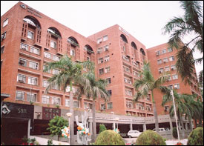
Ranked amongst the top ten public sector companies in India in terms of turnover, SAIL manufactures and sells a broad range of steel products, including hot and cold rolled sheets and coils, galvanized sheets, electrical sheets, structural, railway products, plates, bars and rods, stainless steel and other alloy steels. SAIL produces iron and steel at five integrated plants and three special steel plants, located principally in the eastern and central regions of India and situated close to domestic sources of raw materials, including the Company's iron ore, limestone and dolomite mines. The company has the distinction of being India’s largest producer of iron ore and of having the country’s second largest mines network. This gives SAIL a competitive edge in terms of captive availability of iron ore, limestone, and dolomite which are inputs for steel making.
SAIL's wide ranges of long and flat steel products are much in demand in the domestic as well as the international market. This vital responsibility is carried out by SAIL's own Central Marketing Organization (CMO) and the International Trade Division. CMO encompasses a wide network of 34 branch offices and 54 stockyards located in major cities and towns throughout India.
SAIL has a well-equipped Research and Development Centre for Iron and Steel (RDCIS) at Ranchi which helps to produce quality steel and develop new technologies for the steel industry. Besides, SAIL has its own in-house Centre for Engineering and Technology (CET), Management Training Institute (MTI) and Safety Organization at Ranchi. Our captive mines are under the control of the Raw Materials Division in Kolkata.
MAJOR UNITS OF SAIL
Major Units
Integrated Steel Plants
- Bhilai Steel Plant (BSP) in Chhattisgarh
- Durgapur Steel Plant (DSP) in West Bengal
- Rourkela Steel Plant (RSP) in Orissa
- Bokaro Steel Plant (BSL) in Jharkhand
- IISCO Steel Plant (ISP) in West Bengal

Special Steel Plants
- Alloy Steels Plants (ASP) in West Bengal
- Salem Steel Plant (SSP) in Tamil Nadu
- Visvesvaraya Iron and Steel Plant (VISL) in Karnataka

Joint Venture
NTPC SAIL Power Company Pvt. Ltd
A 50:50 joint venture between Steel Authority of India Ltd. (SAIL) and National Thermal Power Corporation Ltd. (NTPC Ltd.), it manages the captive power plants at Rourkela, Durgapur and Bhilai with a combined capacity of 314 megawatts (MW)

Bokaro Power Supply Company Pvt. Limited
This 50:50 joint venture between SAIL and the Damodar Valley Corporation formed in January 2002 is managing the 302-MW power generation and 1880 tonnes per hour steam generation facilities at Bokaro Steel Plant.

Mjunction Services Limited
A joint venture between SAIL and Tata Steel on 50:50 basis, this company promotes e-commerce activities in steel and related areas.

SAIL-Bansal Service Center Ltd.
SAIL has formed a joint venture with BMW industries Ltd. on 40:60 basis to promote a service centre at Bokaro with the objective of adding value to steel.

Bhilai JP Cement Ltd
SAIL has also incorporated a joint venture company with M/s Jaiprakash Associates Ltd to set up a 2.2 MT cement plant at Bhilai.

BACKGROUND HISTORY OF RDCIS

SAIL's Background and History
A Rich Heritage

The Precursor

SAIL traces its origin to the formative years of an emerging nation - India. After independence the builders of modern India worked with a vision - to lay the infrastructure for rapid industrialization of the country. The steel sector was to propel the economic growth. Hindustan Steel Private Limited was set up on January 19, 1954. The President of India held the shares of the company on behalf of the people of India.

Expanding Horizon (1959-1973)
Hindustan Steel (HSL) was initially designed to manage only one plant that was coming up at Rourkela. For Bhilai and Durgapur Steel Plants, the preliminary work was done by the Iron and Steel Ministry. From April 1957, the supervision and control of these two steel plants were also transferred to Hindustan Steel. The registered office was originally in New Delhi. It moved to Calcutta in July 1956 and ultimately to Ranchi in December 1959.
A new steel company, Bokaro Steel Limited, was incorporated in January 1964 to construct and operate the steel plant at Bokaro. The 1 MT phases of Bhilai and Rourkela Steel Plants were completed by the end of December 1961. The 1 MT phase of Durgapur Steel Plant was completed in January 1962 after commissioning of the Wheel and Axle plant. The crude steel production of HSL went up from .158 MT (1959-60) to 1.6 MT. The second phase of Bhilai Steel Plant was completed in September 1967 after commissioning of the Wire Rod Mill. The last unit of the 1.8 MT phase of Rourkela - the Tandem Mill - was commissioned in February 1968, and the 1.6 MT stage of Durgapur Steel Plant was completed in August 1969 after commissioning of the Furnace in SMS. Thus, with the completion of the 2.5 MT stage at Bhilai, 1.8 MT at Rourkela and 1.6 MT at Durgapur, the total crude steel production capacity of HSL was raised to 3.7 MT in 1968-69 and subsequently to 4MT in 1972-73.

SAIL Today
SAIL today is one of the largest industrial entities in India. Its strength has been the diversified range of quality steel products catering to the domestic, as well as the export markets and a large pool of technical and professional expertise.
Today, the accent in SAIL is to continuously adapt to the competitive business environment and excel as a business organization, both within and outside India.
FUTURE OF RDCIS (SAIL)

SAIL - Into the Future
SAIL’s Growth Plan 2010
Much has happened ever since SAIL’s Corporate Plan was announced in 2004. Investment plans for the three speciality steel plants have been firmed up. Company has grown in size with the amalgamation of IISCO (now renamed as IISCO Steel Plant). Production targets have been revised from 19 million tonnes (MT) of steel to about 24 MT. Estimated investment has increased from Rs 25,000 crore to around Rs 40,000 crore. And the time period has been squeezed by two years, bringing the targeted year of completion of major projects from 2012 to 2010.
Prevailing Scenario
True, SAIL is looking into future and the journey has begun. As of now, projects worth around Rs 28,000 crore are in various stages of implementation. This includes ongoing 28 numbers of projects worth more than Rs 2,800 crore spread over six production units across the country. The tendering for rest of the approved projects worth around Rs 25,000 crore is presently under progress. More importantly, three new production facilities have recently been commissioned at a total cost of Rs 187 crore at Bhilai Steel Plant (BSP).
In a significant development, the company now obtains consolidated approval for the major projects instead of piece meal approvals. For instance, the SAIL board has in the last one year granted ‘in-principle’ approval for the entire package of Rs 1,553 crore of projects for Sales Steel Plant (SSP), Rs 9,592 crore for IISCO Steel Plant (ISP) and Rs 9,265 crore for Bokaro Steel Plant (BSL).
Some of the important ongoing projects include Installation of Slab Caster at Bhilai Steel Plant, Installation of Bloom Caster at Durgapur Steel Plant, Installation of Pipe Coating Plant at Rourkela Steel Plant, Rebuilding of Coke Oven Battery No. 5 and Upgradation of Automation System of Tandem Mill in CRM Complex at Bokaro Steel Plant and Installation of Argon Oxygen Decarburisation (AOD) and High Powered Electric Arc Furnace (EAF) at Alloy Steels Plant.
Technology Marketing, Consultancy and Contract Research:-

RDCIS has introduced several innovations in the SAIL plants towards improvement in the technological performance, cost reduction, quality improvement and development of value added products R & D inputs have contributed significantly towards consistent improvement in the techno economic parameters of SAIL plants.
In recognition of its noteworthy achievements, RDCIS has begged several national awards such as DSIR award, FICCI award, Golden Peacock National Quality award, NRDC award, Rajbhasa award, NMD awards, SAIL Gold Medal, Visvesvaraya Gold Medal, MECON award, Steel Eighties award, Kamani Gold Medal, Essar Gold Medal, National Mineral Award etc.

Having established its credentials within the company and in the iron & steel industry, RDCIS offers technological services to various organizations in the form of:
- Know-how transfer of technologies developed by RDCIS
- Consultancy services
- Specialized testing services
- Contract research
- Training

CONTENTS

Subject Page
- Declaration…..…………………………………………………… 2

- Acknowledgement……………………………………………….. 3

- Company Details………………………………………………. 4

- About project and project tools……………………………….. 10

- Software engineering paradigm………………………………… 12

- Software and Hardware requirement…………………………… 15

- About C and Code::Blocks……………………………………... 16

- Coding and Programme Presentation…………………………… 21

- Screening Display……………………………………………… 40

- Testing………………………………………………………….. 48

- Conclusion & References ……………………………………… 50

ABOUT THE PROJECT
&
PROJECT TOOLS

    - ABOUT THE PROJECT

1. Introduction:-
REQUIRNMENT ANALYSIS

ANANLYSIS AND DESIGN

PRELIMARY INVESTIGATION
Reviewing organization Documents: -
When we reviewed the document of institutions we found following problems:
- Difficulty in issuing books: By the help of register maintaining it is very difficult to know which member has taken how many books.
- Searching is difficult and books are issued to defaulter members also.
- Management of book record is difficult.

Interviewing: Some study feats that came out from these interviews is following:
As a member of library one can see the several obvious problem exits.
- Often it is difficult to search which book is added and when.
- There is a problem of time delay in searching the records of any member.
- It is difficult to maintain the records of members. How many maximum books can be issued to a member or whether he/she is a special member.
- Delay in issuing of books because of hand written data entry.
- So the Employee feel problem to maintain the records.

Feasibility study: Considering on these three types of feasibility study came to the determine that this project is feasibility to implement those Aspects are

Technical feasibility: According to the requirement we selected the client/server system I think this is technically feasible for Library office because in the Libraries of many institutions everything is manually maintained. If the clerk want to see how many books issued to a specific member then it is very time consuming while in client /server system it is very fast.
Operational feasibility: If we consider the operation / feasibility of the system we find that the work had done before some days after the use feel problem on searching the information But this system will provide the immediate search even data in many years old. But By the manual system it is worker can get the benefit to search the data.
- This system will take only validate data and useful data. So it decreases the burden of the member that a user can do any mistake.
- Before these systems when the libraries were using the manual system it leaves many useful data, which can be useful for the clerk or librarian to take important decisions.
- The systems will user friendly so we think user can work on this system after getting one or more days training.
- This system provides a facility to communication other client so one can send required information.
- This system provides the ability to process a certain volume of transaction at particular speed.

- There will be a facility to produce output in a given time.
- It gives Response time under certain condition.

Economic Feasibility: - This system shows Economics feasibility on Basic of following elements: -
Cost – saving benefits: In previous system there are many clerical staff they perform their task manually so there doing tasks are very slow and management have to pay a lot of extra money to pay the extra staff. This system helps the management to reduce the extra staff and this leads to redact in operational cost.
Cost – avoidance benefit: - When workload increases the management hire the additional in casual basis cost. But by this system the management can eliminate future operational costs.
Improved – Information benefits:This system lead to better information for decision making. This information makes it easier to provide better service to all members.

SOFTWARE ENGINERING PARADIGM APPLIED
Why prototype paradigm?
Often, a customer defines a set of general objective for software but does not identify detail input, processing or output requirements. In other cases, the developer may be unsure of the efficiency of an algorithm, the adaptability of an operating system of the form that human/ machine interaction should take. In these, and many other situations, prototyping paradigm may offer the best approach.
The prototyping paradigm begins with requirement gathering. Developer and customer meet and define the overall objective for the software, identify whatever requirements are known and outlines areas. Where the further definition is mandatory. A “quick design focuses on a representation of those aspects of the software that will be visible to the customer/user (e.g. input approaches and output formats). The prototype is evaluated by the construction of a prototype. The prototype is evaluated by the customer/ user and used to redefine requirements for the software to be developed. Iteration occurs as the prototype is tuned to satisfy the needs of the customer, while same time enabling the developer to better understand what need is to be done.
Ideally, the prototype serves as a mechanism of identifying software requirements. If a working prototype is built, the developer attempts to use existing program fragments of applies tools (e.g. report generation) that enable working programs to be generated quickly.
It is true that both customer and developer like the prototyping paradigm. User get feels for the actual system and developers get to build something immediately.
The prototyping paradigm used to may project quality or long term maintainability. In institutions management system can’t enter at a time record.
Organization maintains very large data. Prototype maintains student facility so student can get the record at a time. It is also beneficial for the manager for taking decision. Since data are scattered in the different-different files so it is major problem to prepare report. The management can get only the report of a particular department at a time. Quality management changed accessibly the complete project structure. Prototype paradigm also used to report generator, window manager then working enables working programs to be generated quickly. In prototyping paradigm user get a fill for actual system and developer gets to build something immediately. It includes large number of elements to enables individuals to use the proposed system to determine what they like and to identify feature to be added or changed. Application prototyping, the process of developing, and using the prototype, has the following characteristics:
- The prototype is a live, working application.
- Its main purpose is to test out the assumption made by the analysts and user about the feature of required system.
- Prototypes can be quickly created.
- They follow an iterative process.
- They are relatively chipped.
Application prototype has two primary uses. The first one is that it is an effective device for clerking user requirements. When specification is typically created as a vehicle for defining application feature and requirements the must be satisfied.
A second use of application prototyping is to verify the feasibility of a system design, analysts can make experiment using different application characteristics, evaluating user reaction and response.
The rationale for application prototyping is a direct outgrowth of the need to design and develop information systems quickly, efficiently and effectively. Application prototyping is proven technique that improves the overall effectiveness of the development effort for the benefit of user, analyst and organization as a whole.
Prototype paradigm in my project: After studying all the features of the prototype model we decide to follow this model so we developed the institutions project. So we follow the path of this model for this use to follow the following steps:
- Listen to customer: At first we go to meet the library authority and ask about the system. They gave us a lot of contents and also sent us to the registration counter. On the registration counter we ask many questions to the counter person. After that we contact with the library in charge he also gives me a lot of information of library.
- Build/revise mock-up: On the basis of Performa and information we design the system and create a demo.
- Customer test-drives mock-up: We show that demo to many members they give me a lot of information to make change in the project. We follow their views and again make the changes.
These steps are repeated many times and lastly we think we were able to satisfy the customer in this way I can say that I got a lot of benefits by using prototype paradigm.

Library Management

Library Management is a way of managing the works involved in the LIBRARY like creating new members , deleting members, issuing book, receiving of book, showing the members, report generation on books, members and others processes in an easy way.
It facilitates the ease of working of any Librarian as it contains various special features of They are:-
i)LOV:-(LIST OF VALUES) It is generated on every text boxes so as to make the selection process easier than ever.
ii)ALERT BOXES:- It also generates alert boxes which alert us for the purposes it is generated.
iii) REPORTS:- It also contains reports via which we are able to display the no’s of books and members, total price of the book present in the library in tabular form. we can also generate other reports like letters which can be given automatically to the defaulters who failed to submit the book on time.
It frees the Librarian from the book keeping of records in registers which not only saves their valuable time but also increases the efficiency of their work.

Tools/Environment Used

The tools used in the project tells the end –user that the software will required that tool and the environment used for the project to run properly on any type of system .So, that the software is compatible with all types of systems.
The minimum project /software requirement to run easily are :
I used C language and File Handling for “ Library Management System” (LMS).

Hardware requirement :
- Operating system: Window 7
- Hard disks: 40GB
- RAM: 256 MB

Software requirement :
- Local disk(For storage)
- Code:: Blocks
- C Language

C


 | Paradigm |  |  | Imperative (procedural), structured
 | Designed by |  |  | Dennis Ritchie
 | Developer |  |  | Dennis Ritchie & Bell Labs(creators); ANSI X3J11 (ANSI C); ISO/IEC JTC1/SC22/WG14(ISO C)
 | First appeared |  |  | 1972; 47 years ago^{[2]}
 | Stable release |  |  | C18 / June 2018; 1 year ago
 | Typing discipline |  |  | Static, weak, manifest, nominal
 | OS |  |  | Cross-platform
 | Filename extensions |  |  | .c, .h
 | Major implementations
 | K&R, GCC, Clang, Intel C, Microsoft Visual C++, Watcom C
 | Dialects
 | Cyclone, Unified Parallel C, Split-C, Cilk, C*
 | Influenced by
 | B (BCPL, CPL), ALGOL 68,^{[3]} Assembly, PL/I, FORTRAN
 | Influenced
 | Numerous: AMPL, AWK, csh, C++, C--, C#, Objective-C, D, Go, Java, JavaScript, Julia, Limbo, LPC, Perl, PHP, Pike, Processing, Python, Ring,^{[4]} Rust, Seed7, Vala, Verilog(HDL),^{[5]}
 | Code::Blocks
 | Code::Blocks
 | 
 | Developer(s) | The Code::Blocks team
 | Initial release | 2005; 14 years ago
 | Stable release | 17.12 / December 30, 2017; 18 months ago
 | Repository | - anonscm.debian.org/git/collab-maint/codeblocks.git
 | Written in | C++ (wxWidgets)
 | Operating system | Cross-platform
 | Type | IDE
 | License | GNU GPLv3^{[1]}
About Code::Blocks
Code::Blocks is a free, open-source cross-platform IDE that supports multiple compilers including GCC, Clang and Visual C++. It is developed in C++ using wxWidgets as the GUI toolkit. Using a plugin architecture, its capabilities and features are defined by the provided plugins. Currently, Code::Blocks is oriented towards C, C++, and Fortran. It has a custom build system and optional Make support.
Code::Blocks is being developed for Windows and Linux (the latest macOS version is 13.12 released on 12/26/2013) and has been ported to FreeBSD, and Solaris

Features

Compilers
Code::Blocks supports multiple compilers, including GCC, MinGW, Digital Mars, Microsoft Visual C++, Borland C++, LLVM Clang, Watcom, LCC and the Intel C++ compiler. Although the IDE was designed for the C++ language, there is some support for other languages, including Fortran and D. A plug-in system is included to support other programming languages.

Code editor
The IDE features syntax highlighting and code folding (through its Scintilla editor component), C++ code completion, class browser, a hex editor and many other utilities. Opened files are organized into tabs. The code editor supports font and font size selection and personalized syntax highlighting colours.

Debugger
The Code::Blocks debugger has full breakpoint support. It also allows the user to debug their program by having access to the local function symbol and argument display, user-defined watches, call stack, disassembly, custom memory dump, thread switching, CPU registers and GNU Debugger Interface.

GUI designer
As of version 13.12 Code::Blocks comes with a GUI designer called wxSmith. It is a derivative port of wxWidgets version 2.9.4.^{[6]} To make a complete wxWidgets application, the appropriate wxWidgets SDK must be installed.

User migration
Some of Code::Blocks features are targeted at users migrating from other IDE's - these include Dev-C++, Microsoft Visual C++ project import (MSVC 7 & 10), and Dev-C++ Devpak support.

Project files and build system
Code::Blocks uses a custom build system, which stores its information in XML-based project files. It can optionally use external makefiles, which simplifies interfacing with projects using the GNU or qmake build systems.

Description About The Project:
- FILES:
    - Why we need files?
- Often when data is large, only limited amount of data can be stored in memory and get displayed on the screen.
- Memory is volatile and its contents would be lost once the program is terminated.
DISK
OUR PROGRAM
C Library
Functions
OS

- NUMBER OF FILES CREATED:
- Filename “comp.dat” stored in D-disk, created to store data related to login purpose.
- Filename “comp1.dat” stored in D-disk, created to store book record.

- FUNCTIONS USED:
- Gotoxy Function: Used to place CURSOR at desired position. Header File-Windows.h
- Time Function: Used to extract current time and date from inbuilt function in Header File-Time.h
- Search Function: User defined function to search element.
4)Binary search:
- Binary Search is used to search books in search function.
- Binary Search is the most effective way to search element in sorted data.
- Time Complexity of Binary search is O(log n).
- CHOICES FOR :
- ADMIN:
- ADD BOOKS.
- TIME AND DATE OF RECORD.
- LIST BOOKS.
- EDIT EXISTING RECORD.
- DELETE A RECORD.
- SEARCH A RECORD.
- EXIT
- LOGIN PAGE.
- USER:
- SEARCH BOOK.

//PROGRAM FOR LOGIN
CODING AND PROGRAMME PRESENTATION
#include<stdio.h>
#include<stdlib.h>
#include<windows.h>
struct login
{
char l[100];
char name[100];
char pass[100];
};
void main()
{
int choice;
struct login e;
FILE *fp;
char another='y';
fp=fopen("d:\comp.dat","rb+");
if(fp==NULL)
{
fp=fopen("d:\comp.dat","wb+");
if(fp==NULL)
{
printf("\n file do not exist.");
exit(0);
}
}
system("cls");
while(another=='y')
{
printf("\nMENU:");
printf("\n1.display admin or user,username,password:");
printf("\n2.Enter admin or user,username,password:");
printf("\n Enter your choice:");
scanf("%d",&choice);
switch(choice)
{
case 1:
rewind(fp);
while(fread(&e,sizeof(e),1,fp)==1)
printf("\n%s%s%s\t",e.l,e.name,e.pass);
break;
case 2:
rewind(fp);
while(another=='y')
{
printf("\n Enter admin or user,username,password:");
scanf("%s%s%s",e.l,e.name,e.pass);
fwrite(&e,sizeof(e),1,fp);
printf("\n another record(y/n):");
fflush(stdin);
another=getche();
}
break;
}
printf("\n Enter again (y/n):");
fflush(stdin);
another=getche();
}
fclose(fp);

}
//PROGRAM
#include<stdio.h>
#include<stdlib.h>
#include<windows.h>
#include<string.h>
#include<time.h>
//#include<system.h>
void search();
COORD coord={0,0};
void gotoxy(int x,int y)
{
coord.X=x;
coord.Y=y;
SetConsoleCursorPosition(GetStdHandle(STD_OUTPUT_HANDLE),coord);
}
struct login
{
char l[100];
char name[100];
char pass[100];

};
struct record
{
int l;
char name[100];
char author[100];
long int isbn;
int cop;
char str[100];
};

//FILE *ft;
//ft=fopen("d:\comp1.dat","a+");
void main()
{
time_t t;
FILE *fp,*fs;
int a=0,v,k,r,x,val;
char ano='y',choice;
struct login e,e1;
struct record p;
//struct record p.l=1;
char modbook[100];
char another;
fp=fopen("d:\comp.dat","rb");
//gotoxy(30,10);
j:
while(ano=='y')
{
system("cls");
//clrscr();
gotoxy(30,10);
printf("Enter admin or user:");
scanf("%s",e1.l);
gotoxy(30,12);
printf("USERNAME:");
scanf("%s",e1.name);
gotoxy(30,14);
printf("PASSWORD:");
scanf("%s",e1.pass);
rewind(fp);
while(fread(&e,sizeof(e),1,fp)==1)
{
if(strcmp(e.l,e1.l)==0&&strcmp(e.name,e1.name)==0&&strcmp(e.pass,e1.pass)==0)
{
if(strcmp(e.l,"admin")==0)
a=1;
else
a=2;
break;
}

}
if(a==0)
{
gotoxy(30,16);
printf("Your password is incorrect.Enter again(y/n):");
fflush(stdin);
ano=getche();
}
else
break;
}
fclose(fp);
if(a==1)
{
FILE *ft;
ft=fopen("d:\comp1.dat","rb+");
gotoxy(30,18);
printf("\n You are an admin.");
if(ft==NULL)
{
ft=fopen("d:\comp1.dat","wb+");
if(ft==NULL)
{
gotoxy(30,20);
printf("\n File do not exist.");
exit(1);
}
}
ano='y';
while(ano=='y')
{
system("cls");
gotoxy(30,10);
printf("SELECT FROM CHOICES:");
gotoxy(30,12);
printf("1. ENTER NEW BOOK RECORD.");
gotoxy(30,14);
printf("2. Time and Date of record:");
gotoxy(30,16);
printf("3. List books.");
gotoxy(30,18);
printf("4. Edit existing books.");
gotoxy(30,20);
printf("5. Delete a record:");
gotoxy(30,22);
printf("6. Search a book:");
gotoxy(30,24);
printf("7. Exit:");
gotoxy(30,26);
printf("8. Go to login page:");
gotoxy(30,28);
printf("YOUR CHOICE:");
fflush(stdin);
choice=getche();
switch(choice)
{
case '8':
goto j;
case '1':
rewind(ft);
x=0;
while(fread(&p,sizeof(p),1,ft)==1)
{
p.l;
break;
}
if(p.l==1)
{
while(fread(&p,sizeof(p),1,ft)==1)
{
if(p.l>x)
x=p.l;
}
}
else
{
p.l=0;
}
fseek(ft,0,SEEK_END);
another='y';
while(another=='y')
{
p.l++;
system("cls");
gotoxy(30,10);
printf("Book number %d:",p.l);
gotoxy(30,12);
printf("Enter book name:");
gets(p.name);
gotoxy(30,14);
printf("Enter author:");
gets(p.author);
gotoxy(30,16);
printf("Enter ISBN:");
scanf("%ld",&p.isbn);
gotoxy(30,18);
printf("Enter copies:");
scanf("%d",&p.cop);
time(&t);
strcpy(p.str,ctime(&t));
fwrite(&p,sizeof(p),1,ft);
gotoxy(30,20);
printf("Enter another record(y/n):");
fflush(stdin);
another=getche();
}
break;
case '3':
k=0;
rewind(ft);
system("cls");
while(fread(&p,sizeof(p),1,ft)==1)
{
gotoxy(30,10+10*k);
printf("Details of book number %d:",p.l);
gotoxy(30,12+10*k);
printf("NAME OF BOOK:");
puts(p.name);
gotoxy(30,14+10*k);
printf("AUTHOR OF BOOK:");
puts(p.author);
gotoxy(30,16+10*k);
printf("ISBN:%ld",p.isbn);
gotoxy(30,18+10*k);
printf("COPIES:%d",p.cop);
k++;
}
break;
case '4':
another='y';
while(another=='y')
{
system("cls");
gotoxy(30,10);
printf("Enter book number you want to modify:");
scanf("%d",&v);
rewind(ft);
while(fread(&p,sizeof(p),1,ft)==1)
{
//system("cls");
if(v==p.l)
{
gotoxy(30,12);
printf("BOOK %d:",v);
gotoxy(30,14);
printf("Enter what you want to modify in book number %d.",v);
gotoxy(30,16);
printf("1.Name of book.");
gotoxy(30,18);
printf("2.Author of book.");
gotoxy(30,20);
printf("3.ISBN number.");
gotoxy(30,22);
printf("4.Copies.");
gotoxy(30,24);
printf("Enter your choice:");
scanf("%d",&r);
switch(r)
{
case 1:
gotoxy(30,26);
printf("Enter new book name:");
scanf("%s",p.name);
break;
case 2:
gotoxy(30,26);
printf("Enter author:");
scanf("%s",p.author);
break;
case 3:
gotoxy(30,26);
printf("Enter ISBN:");
scanf("%ld",&p.isbn);
break;
case 4:
gotoxy(30,26);
printf("Enter copies:");
scanf("%d",&p.cop);
break;
}
fseek(ft,-sizeof(p),SEEK_CUR);
fwrite(&p,sizeof(p),1,ft);
break;
}
}
gotoxy(30,28);
printf("Modify another book record (y/n):");
fflush(stdin);
another=getche();

}
break;
case '7':
fclose(ft);
exit(0);
case '5':

another='y';
while(another=='y')
{
system("cls");
gotoxy(30,10);
printf("Enter book number you want to delete:");
scanf("%d",&v);
FILE *fs;
fs=fopen("d:\comp2.dat","wb");
if(fs==NULL)
{
gotoxy(30,12);
printf("\n file do not exist");
}
rewind(ft);
while(fread(&p,sizeof(p),1,ft)==1)
{
if(p.l!=v)
{
if(p.l>v)
p.l--;
fwrite(&p,sizeof(p),1,fs);
}
else
{
gotoxy(30,12);
printf("Book Number %d is deleted.",p.l);
}
}
fclose(ft);
fclose(fs);
remove("d:\comp1.dat");
rename("d:\comp2.dat","d:\comp1.dat");
ft=fopen("d:\comp1.dat","rb+");
gotoxy(30,14);
printf("To delete book:(y/n)");
fflush(stdin);
another=getche();
}
break;
case '6':

//ft=fopen("d:\comp1.dat","rb+"); //while(fread(&p,sizeof(p),1,fp)==1)
search();
break;
case '2':
ano='y';
while(ano=='y')
{
system("cls");
gotoxy(30,10);
printf("Enter Book number:");
scanf("%d",&val);
rewind(ft);
while(fread(&p,sizeof(p),1,ft)==1)
{
if(p.l==val)
{
gotoxy(30,12);
printf("Date and Time are:%s",p.str);

break;
}
}
gotoxy(30,14);
printf("Enter record(y/n):");
fflush(stdin);
ano=getch();
}
break;
}
printf("\nTo go to MENU:(y/n)");
fflush(stdin);
ano=getche();
}
}
else if(a==2)
{
//system("cls");
gotoxy(30,10);
printf("You are an user.");
search();
}
else
printf("\nInvalid input.");
}
void search()
{
FILE *ft;
ft=fopen("d:\comp1.dat","rb+");
int mid,r,a=0,val,lower=0,upper,i,flag=0;
int arr[100];
struct record p;
char another='y';
while(another=='y')
{
system("cls");
rewind(ft);
while(fread(&p,sizeof(p),1,ft)==1)
{
if(p.l>a)
a=p.l;
}
r=p.l;
upper=r-1;
for(i=0;i<r;i++)
arr[i]=i+1;
gotoxy(30,12);
printf("Enter book number to search:");
scanf("%d",&val);
for(i=0;i<r;i++) //BINARY SEARCH
{
mid=(upper+lower)/2;
if(arr[mid]<val)
lower=mid+1;
else if(arr[mid]>val)
upper=mid-1;
else
{
flag=1;
break;
}
}
if(flag==1)
{
gotoxy(30,12);
printf("Book number %d is present.",val);
}
else
{
gotoxy(30,12);
printf("Book number %d is not present.",val);
return;
}
rewind(ft);
while(fread(&p,sizeof(p),1,ft)==1)
{
if(p.l==val)
{
gotoxy(30,14);
printf("details of book number %d:",p.l);
gotoxy(30,16);
printf("NAME OF BOOK:");
puts(p.name);
gotoxy(30,18);
printf("AUTHOR OF BOOK:");
puts(p.author);
gotoxy(30,20);
printf("ISBN:%ld",p.isbn);
gotoxy(30,22);
printf("COPIES:%d",p.cop);
break;
}
}
gotoxy(30,24);
printf("Search another record:(y/n)");
fflush(stdin);
another=getche();
}
fclose(ft);
}

FORM DESIGN

PROJECT RUN

- Form 1 as login Form
Design View
This is the first view when user runs the application.

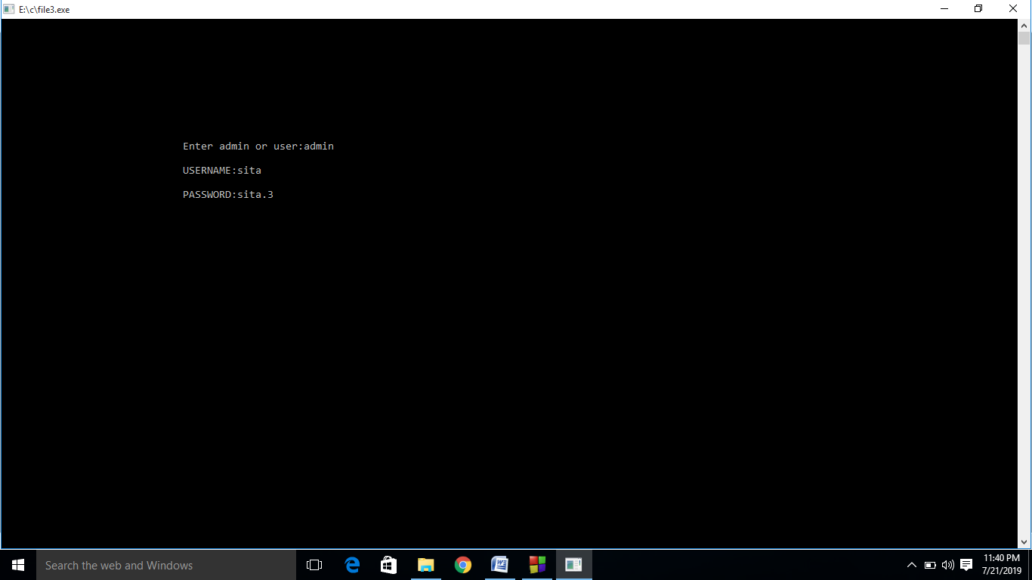

Form 2 as Menu
Design View
This is the menu in library
.
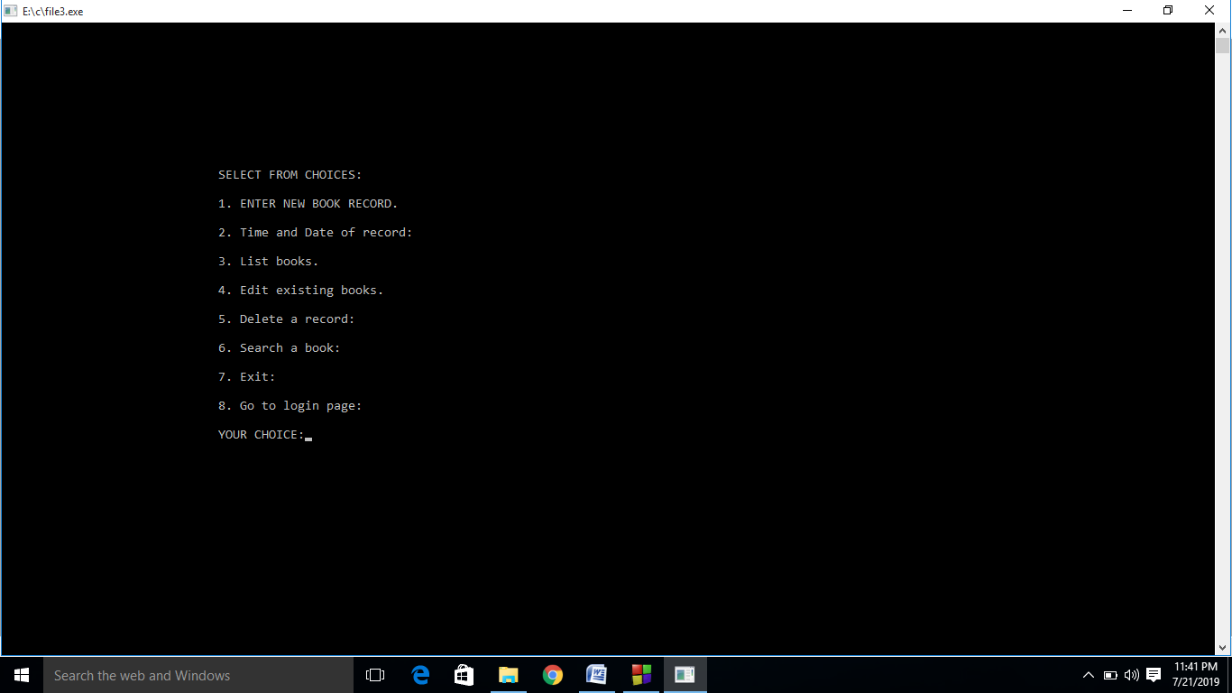

Form 3 as Add book deatils
Design View
This is the add book details.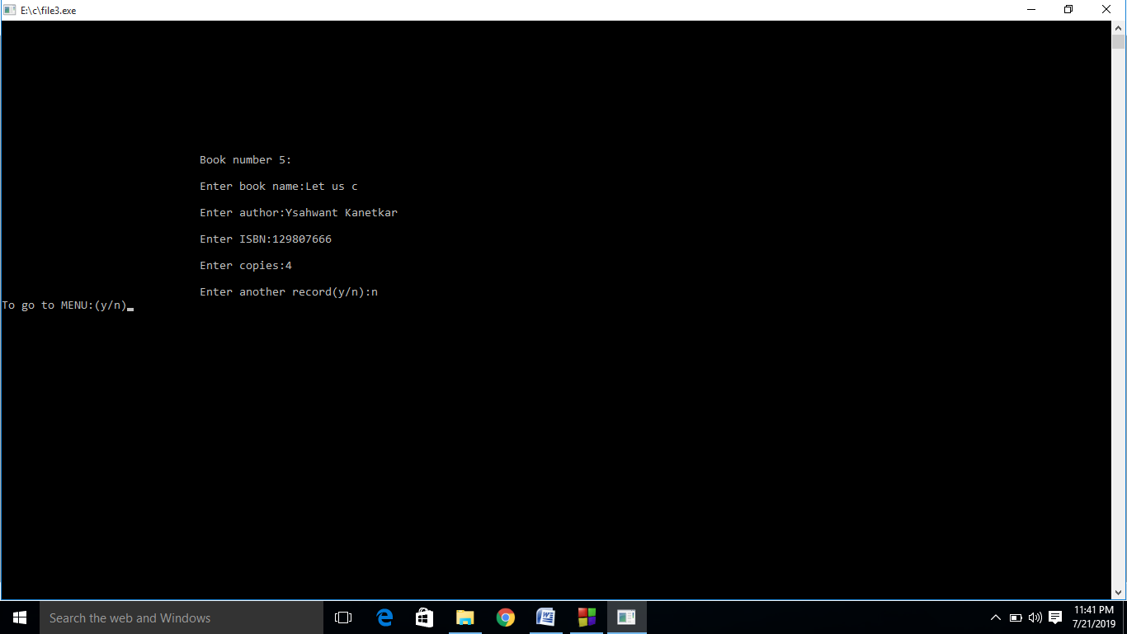

.

Form 4 as Time and Date
Design View
This is the Time and Date of books entered in library.
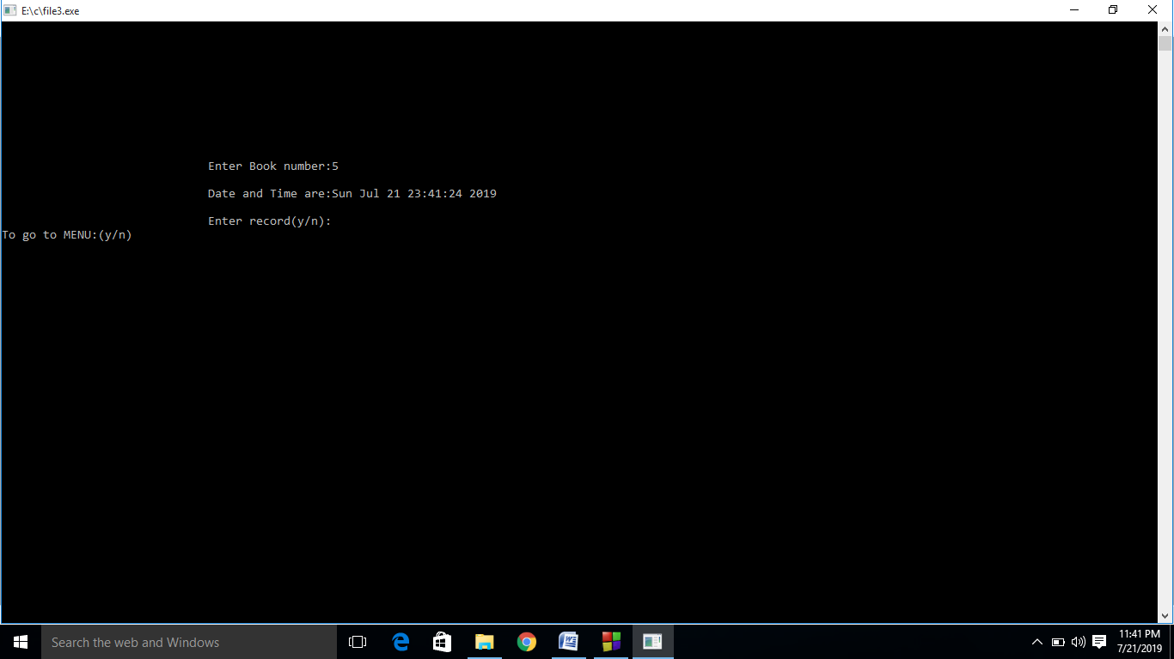

Testing
No program or system design is perfect. Communication between the user and the designer is not always complete or clear and time is usually short. The result is errors and more errors. Thus the time comes to put all the pieces into one system and test it to determine whether it meets the user’s requirements.
Testing is vital to the success of the system. System testing makes a logical assumption that if all the parts of the system are correct, the goal will be successfully achieved. Inadequate testing or non-testing leads to errors that may not appear until months later. This creates two problems: (i) the time lag between the cause and the appearance of the problem and (ii) the effect of system errors on files and records within the system. A small system error can conceivably explode into a much larger. Effective testing in the early process translates directly into long-term cost savings from a reduced number of errors.
Another reason for system testing is its utility as user-oriented vehicle before implementation. The best program is worthless if it does not meet user needs.
Future Scope

FUTURE SCOPE OF APPLICATION:

This application can be easily implemented under various situations.
We can add new features as and when we require. Reusability is
Possible as and when require in this application. There is flexibility
in all the modules.
SOFTWARE SCOPE:

 Extensibility: This software is extendable in ways that its original
Developers may not expect. The following principles enhances
Extensibility like hide data structure, avoid traversing multiple
links or methods, avoid case statements on object type and
distinguish public and private operations.
 Reusability: Reusability is possible as and when require in this
application. We can update it next version. Reusable software
reduces design, coding and testing cost by amortizing effort
over several designs. Reducing the amount of code also
simplifies understanding, which increases the likelihood that
the code is correct. We follow up both types of reusability:
Sharing of newly written code within a project and reuse of
previously written code on new projects.

 Understandability: A method is understandable if someone other
than the creator of the method can understand the code (as
well as the creator after a time lapse). We use the method,
which small and coherent helps to accomplish this.

 Cost-effectiveness: Its cost is under the budget and make within
given time period. It is desirable to aim for a system with a
minimum cost subject to the condition that it must satisfy the
entire requirement.
Scope of this document is to put down the requirements, clearly
identifying the information needed by the user, the source of the
information and outputs expected from the system.
Conclusion

From a proper analysis of positive points and constraints on the component, it can be safely concluded that the product is a highly efficient GUI based component. This application is working properly and meeting to all user requirements. This component can be easily plugged in many other systems.

Bibliography

Books:
 File Handling,Let us C, Yashwant Kanetkar,15th Edition.

WEBSITES:
 www.wikipedia.com

